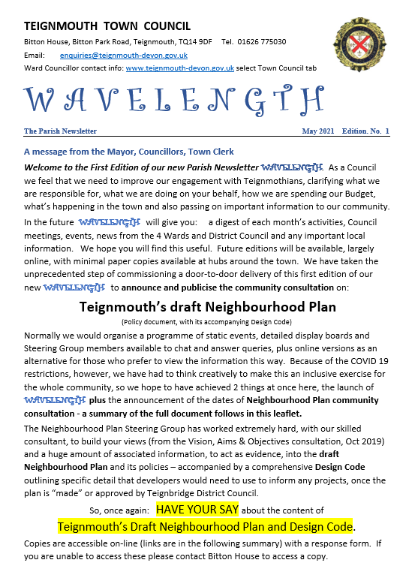
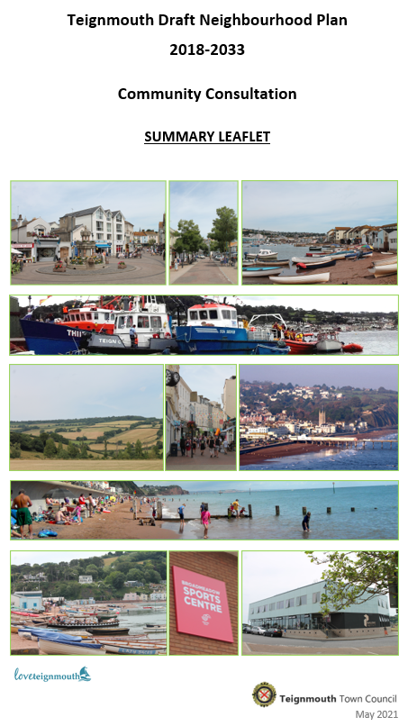
Introduction
This leaflet explains what a Neighbourhood Plan is, what has been done to date and how you can see and comment on the draft Plan. It summarises the Plan’s areas of focus and the headings of the planning policies it contains.
The full draft version of the Plan can be viewed online on the Town Council website https://www.teignmouth-devon.gov.uk/Neighbourhood_Plan_18991.aspx or you can request access to a copy via the contact details on page 8.
We have decided not, at this time, to hold any public events or meetings about the Plan due to the Covid-19 pandemic.
What is a Neighbourhood Plan?
A Neighbourhood Plan is a planning strategy produced for local areas. It is produced, typically, for parishes or towns, for a 10-15 year period. Not all parishes or towns produce a Neighbourhood Plan and so it is an optional planning document. Once the Plan has gone through the required procedures and tests, it carries statutory “weight” in the planning system and has to be taken into account by Teignbridge District Council, alongside national planning policies and “material considerations”, when considering planning applications. When finalised it will form part of the “development plan” alongside the adopted Teignbridge Local Plan.
The Plan must only have policies which relate to land-use planning and development matters. It should not repeat other planning policies, and should add local detail not already provided by Local Plan policies. Those actions, programmes and projects which do not typically require planning permission or are not about the use of land or buildings will not have policy coverage, although they can be referenced in the Plan if they help to convey wider issues of importance. The Plan must pass tests set by the Government, including conformity with national and District planning policies and undergoing public consultation.
What area does the Plan cover?
The Plan covers the Town Council (parish) area, denoted by the red line on the map on the following page.
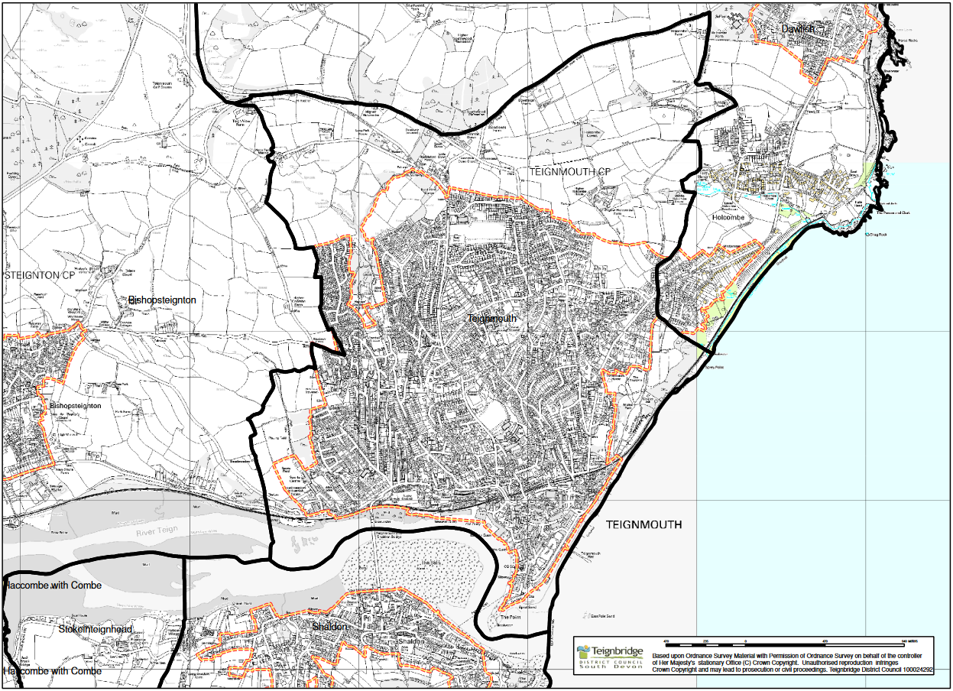
© Crown copyright and data base right, Ordnance Survey licence number (0100050966), 2021
Designated Neighbourhood Plan Area
What have we done so far?
Work started on the Neighbourhood Plan in 2018 when the Town Council formed a Steering Group to develop the Plan. The Group comprises members of the community and Town Councillors.
Before now, two “rounds” of local consultation have taken place, with a community questionnaire and consultation on the vision, aims and objectives of the Plan during 2019. These were aimed at helping us get started and clarify the key issues of importance to those living in the town. Details of both consultations are available on the Town Council website.
What is this consultation about?
This is the community’s first chance to see a full draft of the Plan. As the Plan is about the future of Teignmouth, it is important that residents and business owners are the first to see the draft Plan to help shape it further.
Alongside the Plan, there is a draft Design Code for the town. We are also seeking comments on this document, which provides detailed guidance to planners, developers and others with a responsibility for the built environment on what constitutes “good design” in Teignmouth.
It is important to distinguish between this consultation on the draft Neighbourhood Plan and the forthcoming Teignbridge District Council consultation on the district-wide new Local Plan (Part 2). While the two documents are linked, they are not the same thing.
What are the main topics and policies in the Plan?
The main topics and policy headings are set out below. We have not reproduced policy wording due to limitations on space in this leaflet and encourage you to take a look at the draft Plan to view them in full.
Built Environment
- Policy BE1: Heritage and the Historic Environment
- Policy BE2: High-quality Design
- Policy BE3: Sustainable Design
- Policy BE4: Location of New Development
- Policy BE5: Civic Spaces and the Public Realm
- Policy BE6: Flood Risk
- Policy BE7: Protecting Local Amenity
Housing
- Policy HO1: Engaging with the Community on Major Housing Proposals
- Policy HO2: Flats Above Retail and Other Town Centre Premises
Sport, Leisure and Recreation
- Policy SLR1: Local Green Space
- Policy SLR2: Improving Opportunities for Sports, Leisure and Recreation (Land and Water)
- Policy SLR3: Marine-related Activities
- Policy SLR4: Water Sports Centre at Polly Steps
- Policy SLR5: Supporting Provision for Gymnastics
Community Facilities and Services
- Policy COM1: Protecting Community and Health Facilities, Amenities and Assets
- Policy COM2: Maintaining and Enhancing Community and Health Facilities, Amenities and Assets
- Policy COM3: Telecommunications
- Policy COM4: Safeguarding Land at Park Hill for Enhancements to Facilities for Children and Young People
- Policy COM5: Development of Facilities for Children and Young People
- Policy COM6: Education and Learning Facilities
Town Centre and Retail
- Policy TCR1: Protecting and Enhancing the Pier
- Policy TCR2: Change of Use from Commercial to Residential Use in the Town Centre
- Policy TCR3: Active Shopfronts
- Policy TCR4: Enhancing the Townscape and Civic Spaces with New Trees and Planting
Tourism, Arts and Culture
- Policy TAC1: Supporting the Arts and Cultural Offer
- Policy TAC2: Maintaining and Enhancing Facilities and Amenities on the Sea-front
- Policy TAC3: Local Tourism Opportunities
- Policy TAC4: Loss of Tourism Facilities
- Policy TAC5: New Holiday Accommodation
- Policy TAC6: Loss of Public Houses
Transport, Accessibility and Parking
- Policy TAP1: Improving Transport, Accessibility and Connectivity
- Policy TAP2: Bitton Park Road Settlement Gateway Opportunity Area
- Policy TAP3: Exeter Road / A379 Settlement Gateway Opportunity Area
- Policy TAP4: Town Centre Access from Train Station Opportunity Area
- Policy TAP5: Junction between The Triangles, Regent Street, The Esplanade and Hollands Road
- Policy TAP6: Establishing a Dedicated Cycle and Multi-use Route through the Town Centre
- Policy TAP7: Traffic Arising from Major Development
- Policy TAP8: Parking in Residential Development
- Policy TAP9: Protecting Existing Off-street Car Parking Capacity for Public Use
- Policy TAP10: Preventing Loss of Car Parking Capacity
- Policy TAP11: Creating New Additional Off-street Car Parking Capacity
- Policy TAP12: Electric Charging Points for Plug-in Vehicles
- Policy TAP13: Protecting the Footpath, Bridleway and Cyclepath Network
Natural Environment
- Policy NE1: Locally Valued Landscapes
- Policy NE2: Locally Valued Areas of Biodiversity, Geodiversity and Habitat
- Policy NE3: Teignmouth – Holcombe and Southern Dawlish Local Gap
- Policy NE4: Protecting Trees from Loss
- Policy NE5: Marine Conservation
- Policy NE6: Coastal Erosion
- Policy NE7: Sea Wall and Groynes
Employment, Economy and Business
- Policy EEB1: Small Employment Starter / Incubator Units and Work Hubs to Support the Local Economy
- Policy EEB2: Live-work Units
- Policy EEB3: Supporting the High-tech Sector
- Policy EEB4: Teignmouth Port / Docks
- Policy EEB5: Fish Quay
Renewable and Low Carbon Energy and Waste
- Policy RLC1: Small-scale Renewable and Low Carbon Energy
How can I respond?
A comments form is available on the website here https://www.teignmouth-devon.gov.uk/Neighbourhood_Plan_18991.aspx We would appreciate it if you can use this form to make your comments so that it is easier for us to analyse them. Alternatively, please structure your comments to respond to particular policies or sections of the Plan.
Comments can be posted or emailed to the Town Council at the addresses below (see “Where can I find out more?” on pages 7 and 8).
Comments are welcomed by Monday 14th June 2021. If you miss this deadline, there will be further opportunities to comment on revised versions of the Plan (see “What’s next?” on the last page of this leaflet).
Where can I find out more?
You can see a full version of the draft Plan, Design Code and supporting documents on the Town Council website at https://www.teignmouth-devon.gov.uk/Neighbourhood_Plan_18991.aspx
If you wish to see a paper copy of the Plan, in the interests of accessibility we have copies available to those who need to see it on paper. However, in the interests of sustainability we have printed only a limited number of these. You can request a copy by contacting the Town Clerk via the email address, phone number or postal address below.
Post: Neighbourhood Plan Consultation, Teignmouth Town Council, Bitton House, Bitton Park Road, Teignmouth, TQ14 9DF.
E-mail: NHP@teignmouth-devon.gov.uk Tel.: 01626 775030
What’s Next?
This consultation on the first draft Plan closes on 14th June 2021. The Neighbourhood Plan Steering Group will then review all comments submitted and consider changes to the Plan as a result.
The Plan will then be revised over the summer. We will also then have had the opportunity to consider the emerging new Teignbridge Local Plan (Part 2) and will adjust the Neighbourhood Plan as necessary to ensure that it aligns with that Local Plan, as required by national planning rules.
We intend to publish the revised Neighbourhood Plan for the first legally required consultation, called the Pre-submission or Regulation 14 consultation, in the Autumn. This consultation widens out beyond the local community to include statutory consultees such as local authorities, Government agencies and others likely to have an interest in the Plan. Comments will be reviewed and changes to the Plan made as a result.
The Plan can then be submitted to Teignbridge District Council. We aim to submit the Plan by early next year. The District Council then runs a final consultation, after which comments and the Plan itself are considered by an independent Examiner at a Public Examination. The Examiner will assess the Plan using tests set by the Government. If the Plan passes those tests, it will be finalised and be subject to a local Referendum when all eligible residents in the Plan area (parish) will vote on whether to accept the Plan for use in the planning system. If a majority support the Plan, it becomes a legal planning document in the planning system, being “made” (formally adopted) by Teignbridge District Council.
THANK YOU. PLEASE HAVE YOUR SAY!

